Introduction to Databases on AWS
Relational databases
- Relational databases organize data into tables.
- Tables can be linked to one another, forming relationships between data.
- Each table stores data in rows and columns:
- A row (record) represents a single entry.
- A column represents an attribute of that entry.
- Multiple tables together form the structure of a relational database.
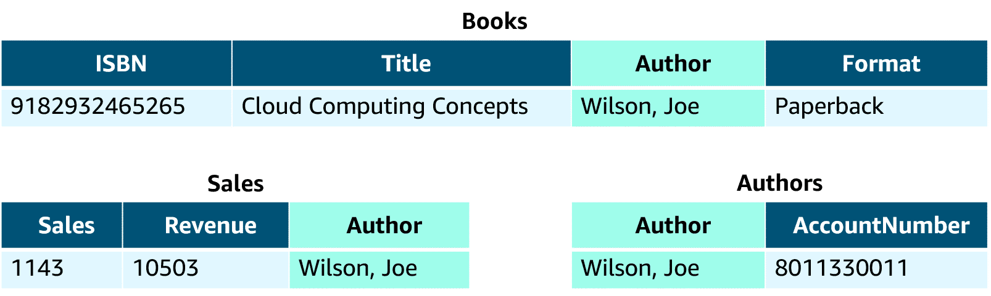
Relational database management system
- A Relational Database Management System (RDBMS) allows you to create, update, and manage relational databases.
- Common RDBMS examples:
- MySQL
- PostgreSQL
- Oracle
- Microsoft SQL Server
- Amazon Aurora
- You interact with an RDBMS using Structured Query Language (SQL).

- Example query:
SELECT * FROM table_name;
→ Retrieves all data from a specific table.
- SQL enables complex queries across multiple tables to find patterns or insights.
- Joins allow combining data from related tables—e.g., linking a sales table with a books table to analyze sales by author.
Benefits
- Complex SQL
- Reduced redundancy
- Familiarity
- Accuracy
Managed and unmanaged databases
Unmanaged
- Unmanaged databases require you to handle most management tasks yourself.
- On-premises:
  - You are responsible for everything — including data center security, hardware, OS, database management, query optimization, and customer data.
- On Amazon EC2:
  - AWS manages the physical infrastructure, hardware, and EC2 OS installation.
  - You manage the EC2 instance, database, queries, and data.
- This setup is called an unmanaged database option — AWS handles the infrastructure, while you handle database operations and management.
- Responsibility shift:
  - On-premises → you manage everything.
  - On EC2 → AWS manages infrastructure; you manage the rest.
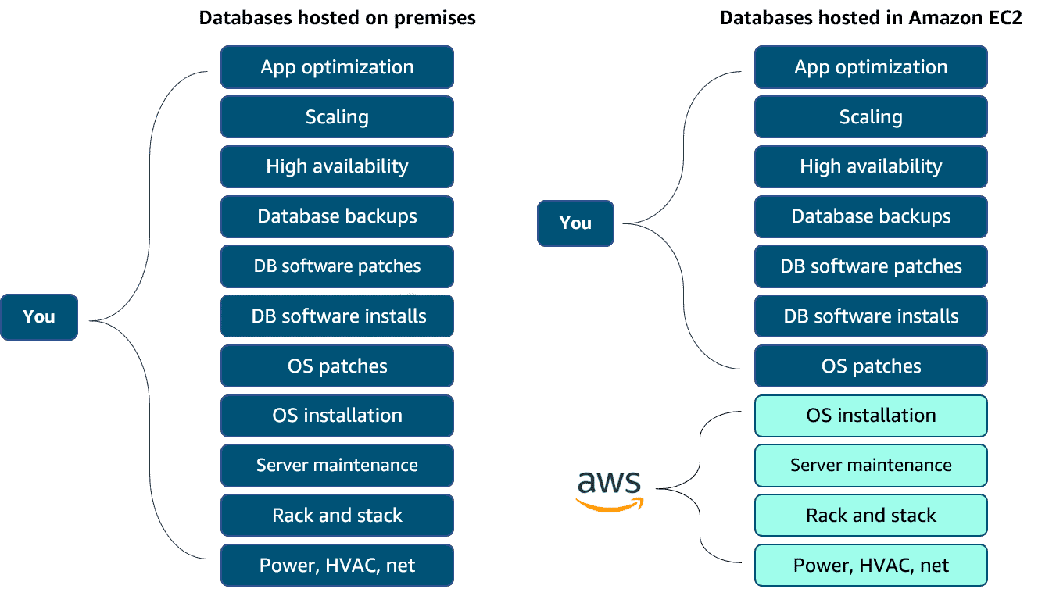

Managed database
- Managed database services shift more operational work to AWS.
- AWS handles EC2 instance setup, database setup, high availability, scaling, patching, and backups.
- You are still responsible for database tuning, query optimization, and data security.
- This option offers the greatest convenience, but less control compared to on-premises or EC2-hosted (unmanaged) databases.
